

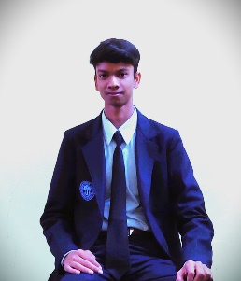Rishi Prasad Maurya

Mobile No: 9305769696

Email: automationrishiald@gmail.com

CAREER OBJECTIVE   
To be a part of an organization where I can effectively contribute my knowledge and enhance my skill to meet company goals.

EDUCATION

|  |  |  |  |  |
| --- | --- | --- | --- | --- |
| **Qualification** | **Board/University** | **Institution**  **Name** | **Year of Passing** | **Percentage Secured** |
| BCA  (Pursuing) | State University | Shambhunath College of Education | 2023 | 76% |
| Intermediate | Central Board of Secondary Education | Maharishi Vidya Mandir Shahdol Madhya Pradesh | 2021 | 85% |
| High School | Central Board of Secondary Education | Oasis Sainik School Hanumangarh Rajasthan | 2019 | 75% |

TECHNICAL SKILLS

* YouTube (Search Engine Optimisation)
* C,C++,JAVA
* HTML,CSS

____________________________________________________

COMPUTER SKILL

* MS Power Point,MS Word
* Driver Management

____________________________________________________

EXTRACURRICULAR ACTIVITIES

* Editing Template,LOGO Designing,Banner designing

FIRST LOGO (Gaming Logo)

* Participated in Skating Puzzle Solving Competition Organized by School.

ACHEIVEMENTS

* I Designed a website based on HTML,PHP,CSS in Year 2020.
* We Won a Gaming Tuornament of half Lakh(that why I want to became Game Developer having much interest in Gaming Field.

HOBBIES

* Playing Basketball
* Skating ,Swimming
* Puzzle Solving
* Inspiring People

STRENGTH

* Having a peace (control ) Brain sense
* Determination & obsession towards My goal
* Self Dependent (never depending or trusting other maintaining limit of anything)

____________________________________________________

PERSONALS DETAIL

* Father Name-Shripati Maurya
* DOB-24 june 2003
* Nationality-Hindi
* Martial Status-Single
* Language Known-English ,haryanvi ,Rajasthani
* Address -Sarai Daud Urf Dhakpura,Mailahan,Phulpur,Allahabad.

DECLARATION I hereby declare that the above mentioned details are true to

the best of my knowledge

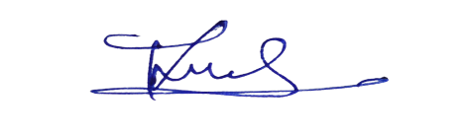**Date**: 23 November 2022 RISHI PRASAD MAURYA

**Place**:Shambhunathe College of

Education Jhalwa Prayagraj